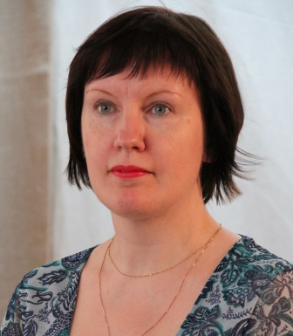
Ekaterina Voronova,
teacher of Karelian College of Culture and Arts,
translater of the project "Dancing Whirlpool"

English without textbooks

There is no doubt that participation in international projects does lots of good to all of those who are engaged in them. Besides new professional skills and impressions, positive assimilation and sharing experience, it gives great motivation to learning foreign languages, especially English, which is spoken all over the world. This is incredibly useful nowadays as many people make great efforts to learn English: they spend a lot of money money on language schools and courses, try different methods of language learning, but don't always succeed. At the same time participants of Russian-Finnish projects in the field of culture get an exellent opportunity to improve their speaking skills while taking part in the project. They need to understand their partners when they are immersed into the dancing atmosphere, when they are learning and working together and just in every minute of their every-day life. That is a very useful experience since being modern and successful also means the ability of speaking foreign languages, and moreover, international coordination develops mutual friendship and understanding. If one knows a foreign language and is interested in it, he will never be secluding himself away. Vice versa, he will make contacts with people of another culture and his intellectual and cultural horizons will become wider.
Nowadays English is needed as the main and the most efficient means of information exchange between the people of our planet. It is quite important as Russia is being integrated into the world community. Thus, Finnish populance can be an example for us. It is well-known that the majority of Finnish people are able to speak English fluently. Thanks to communication with them we can raise our professional level, and English is compulsory again.
The students who participate in the international project "Dancing Whirpool" got a unique chance to enrich their English vocabulary: at first it is just on the intuitive level as they guess the meaning of the words through gestures, motions, signs and movements. It develops their linguistic intuition and flair as well. Unimpugnably, Finnish participants come up with progress in English and make a raise too. More than that, students continue communacation beyond the scope of the project, enriching the world community with some new amicable contacts. That is a great instance of mutually beneficial partnership. Then, it turns out to be a new step in the education and the career of students because a foreign language is necessary for the development of arts in the modern society. Now it is a common experience to get higher education abroad, that is why English opens the door to Finland, Sweden, Norway and many other European countries. Apart from that, it enlarges one's world outlook, cultural scope, general competence and bounds of general education.

