Beauty that fosters the development of international relations

«Dancing whirlpool» is an international project which is implemented within the framework of cross-border cooperation program European Neighbourhood and Partnership Instrument «Karelia» (ENPI CBC Karelia).
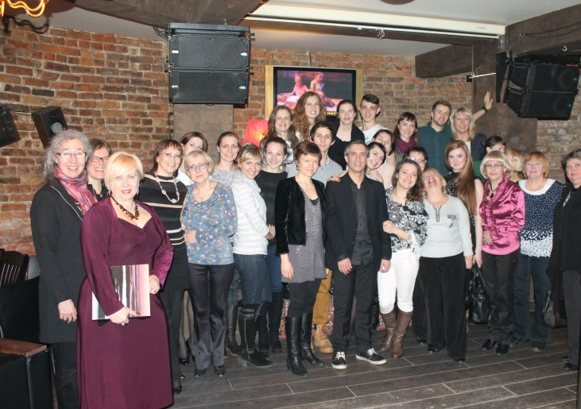
In 2013 Karelian College of Culture and Arts, which plays the role of the leading partner, together with professional college of North Karelia in Outokumpu held series of master classes for students of dance departments of educational institutions on both sides of the border: Russia and Finland and created a dance performance which was masterfully played on different stages including the stage of National Finnish theater in Petrozavodsk.
According to the comments of the participants of the project the most meaningful and fruitful activity was not so much the performance itself (if some people had controversial opinion about it, then it happened only because of a serious lack of knowledge in the field of contemporary art) but rather the preparation for the performance and the invaluable experience that guys absorbed with each repetition. During the project the students used a completely new practices into their usual dance, immersed in completely unknown or sometimes atypical in understanding the viewer images.
Uniqueness is also in significantly different approaches of choreographers to the formulation how to retell the story and if it is necessary to do at all? what proportion of academism should be demonstrated by a dancer or perhaps he doesn't have to surprise the viewer with grand battement zhete (lifting an extended leg to 90 degrees) ? With the introduction of the ethno-cultural component in the dance of the modern era and post-modern dance, absolutely new tasks pursued by the duo -director and performer come out to the forefront. It is nice to know that Karelia, retaining its specificity and imposing shade of identity in contemporary art, including choreography, is keeping pace with the advanced countries in the field of contemporary dance and its development.
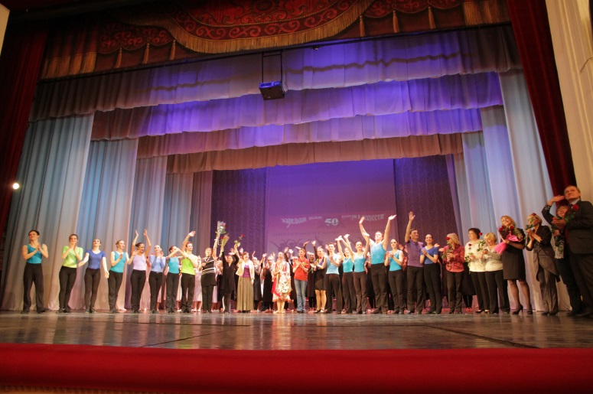
Infecting love to sincere aesthetic creativity, project partners whirlwind swept the cities of Karelia and even managed to go beyond the region in order to inspire the surrounding regions to develop modern dance. In March all dance teams which were somehow involved in «Dancing whirlpool» took part in the final event of the project - the festival of modern choreography for participants of youth dance studios. The author is not able to convey the delight of what he saw. We can only say for sure, taking into account the hype which was caused by this event - enthusiasm and willingness to see something amazing were easily read in the eyes of all the viewers - such events should be held much more often in Karelia and in Petrozavodsk. And not just because each viewer can immerse himself in a huge world, full of beauty and charm for a few hours, but also because he can forever remain a part of it inside.

